Setup a virtual machine using Ubuntu image.
Open aws and click on launch instance and select the instance type as more than t3.micro and ami as ubuntu and click on launch instance
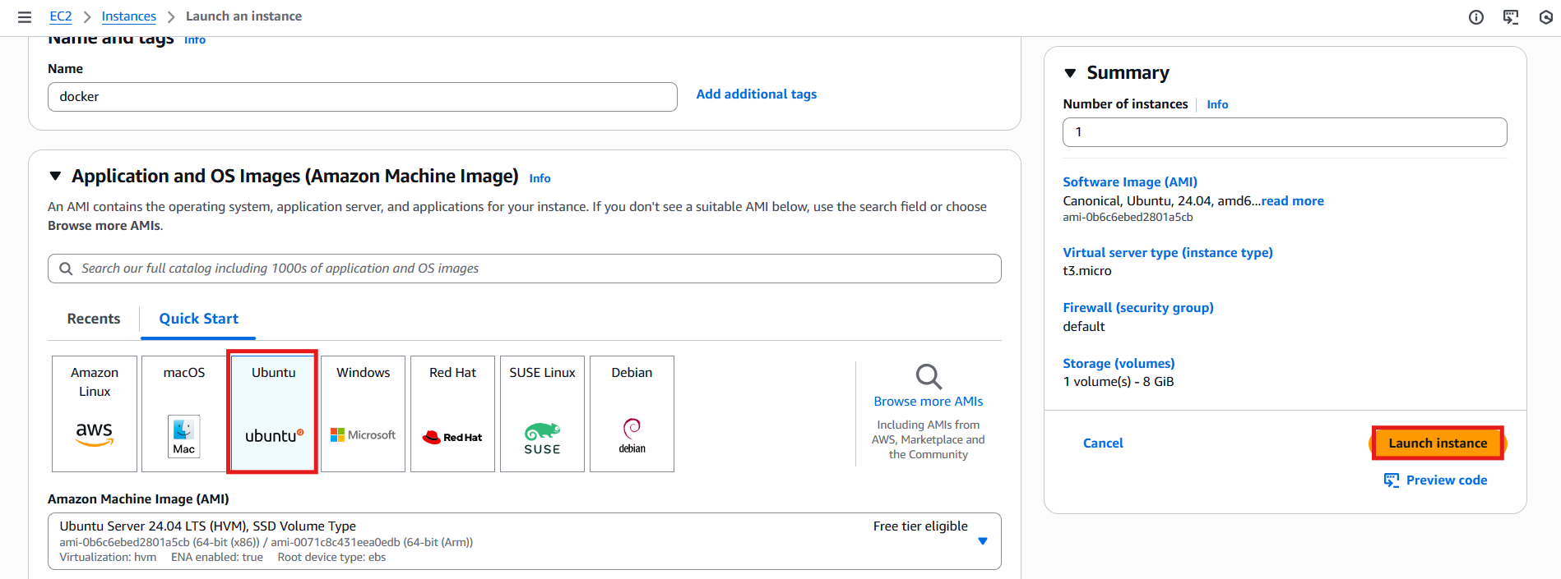
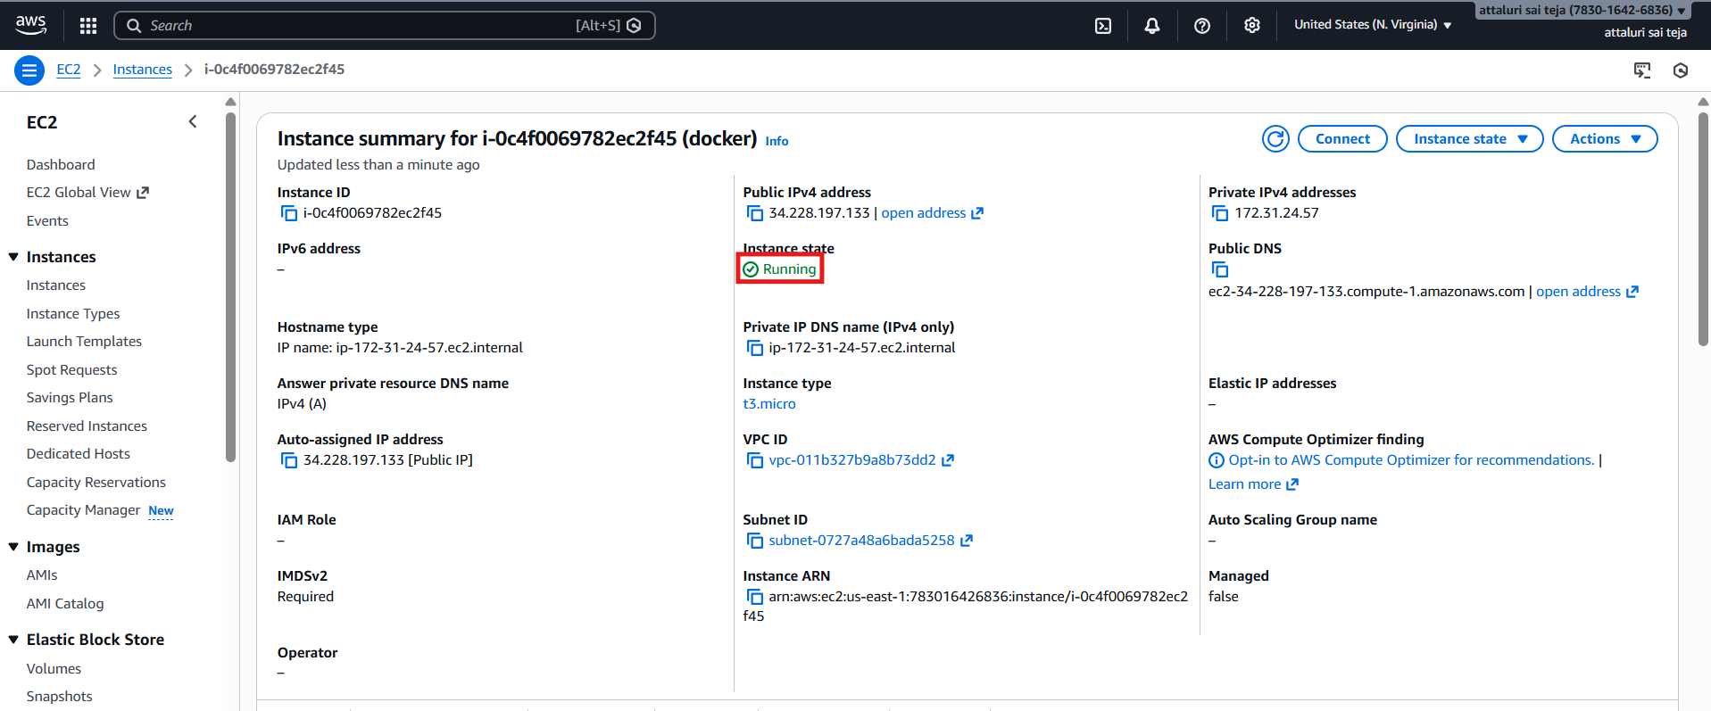

Install docker on ec2
Connect to server and update the packages.. apt update -y
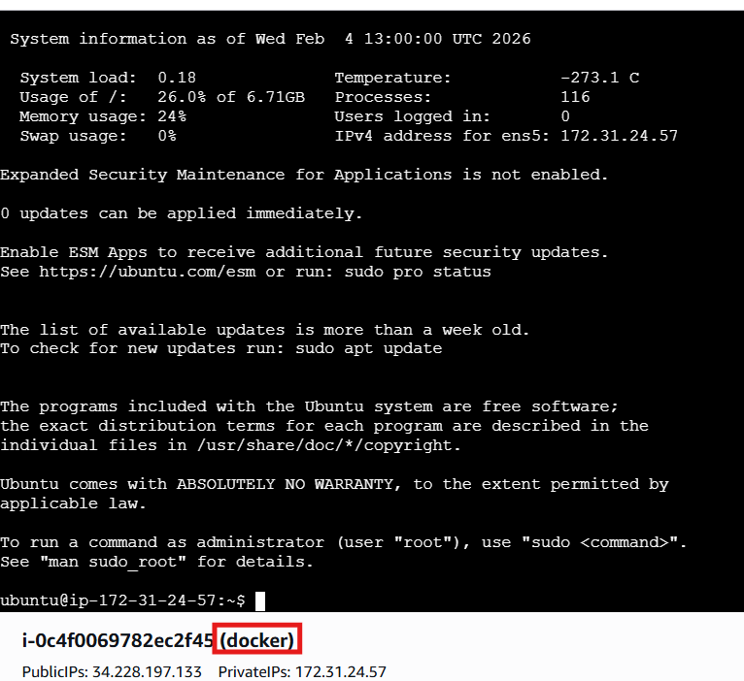
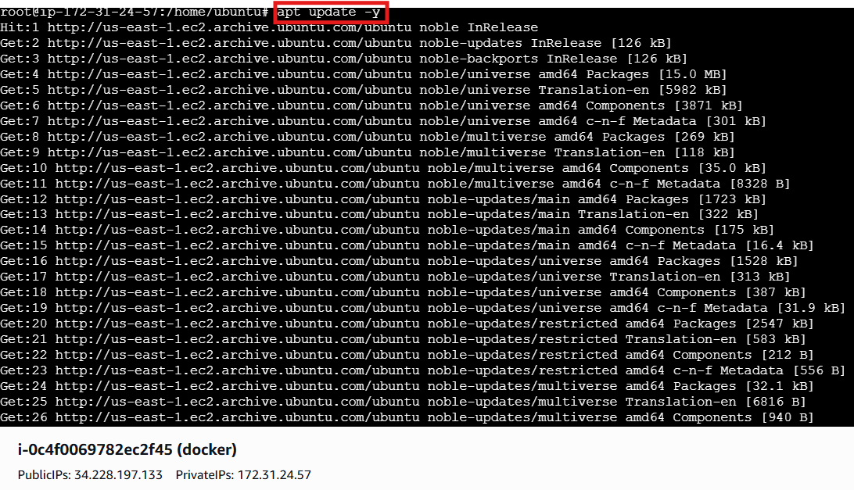
And install the docker using apt install docker.io commands
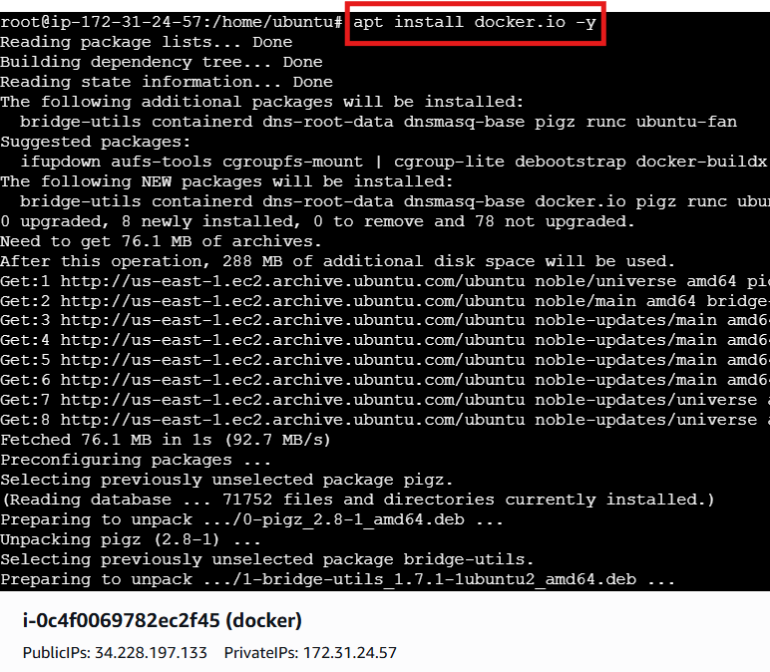
Checked the status of docker and it was running successfully
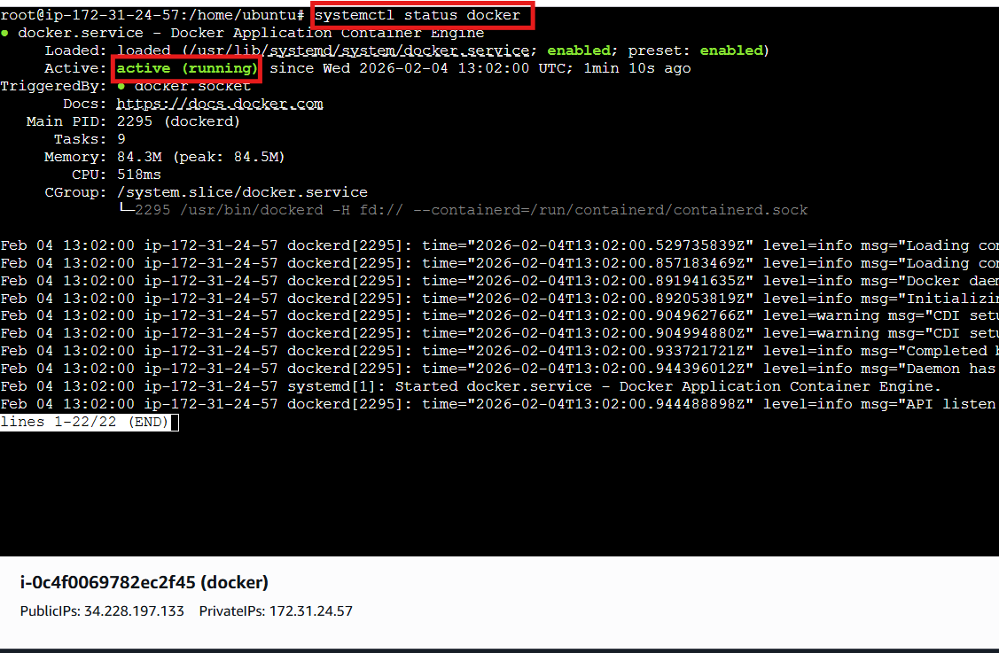
Pull 5 docker images.(nginx,apache tomcat,ubuntu,jenkins,sonarqube)
Use the commands docker pull to download the images
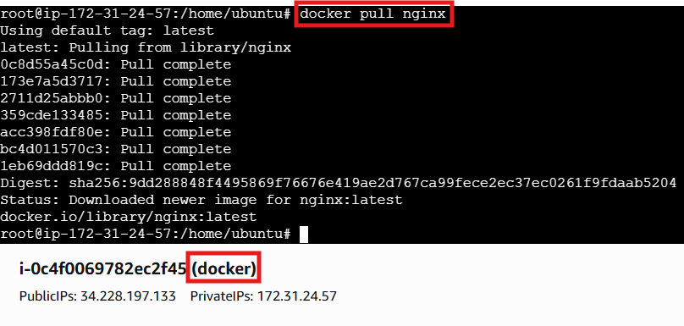

Docker pull tomcat
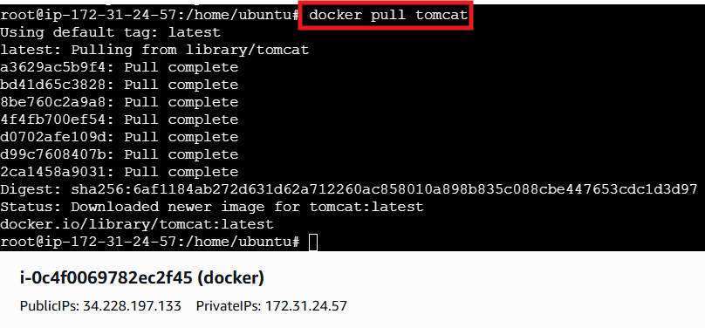
Docker pull ubuntu
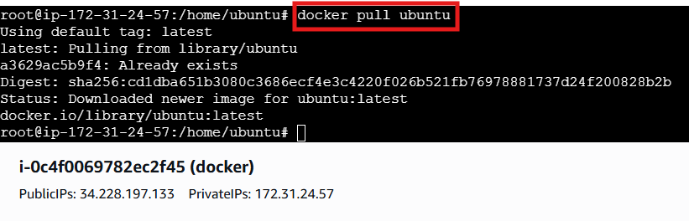
Docker pull sonarqube
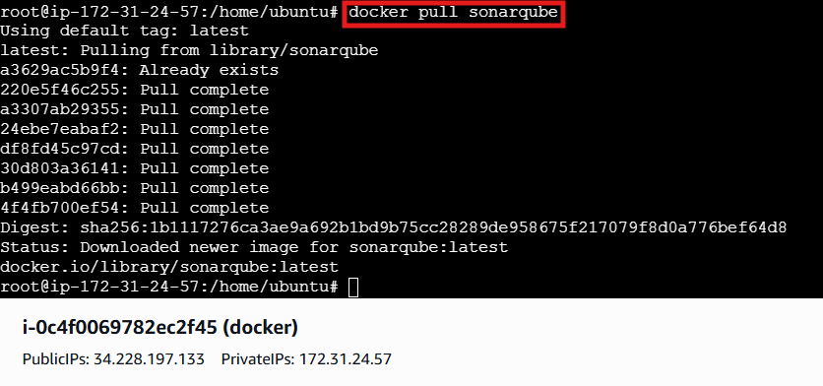

For Jenkins we executed the same command but there was an issue in package type
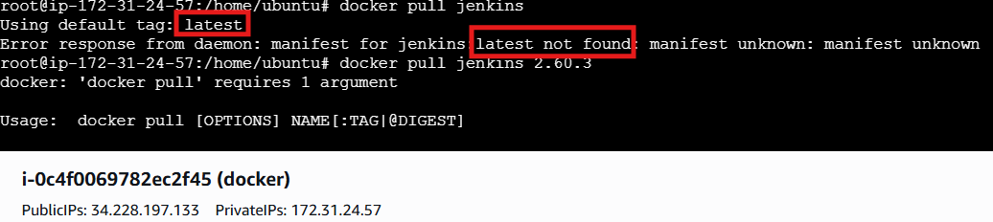
So that open docker hub and select the Jenkins package name and apply
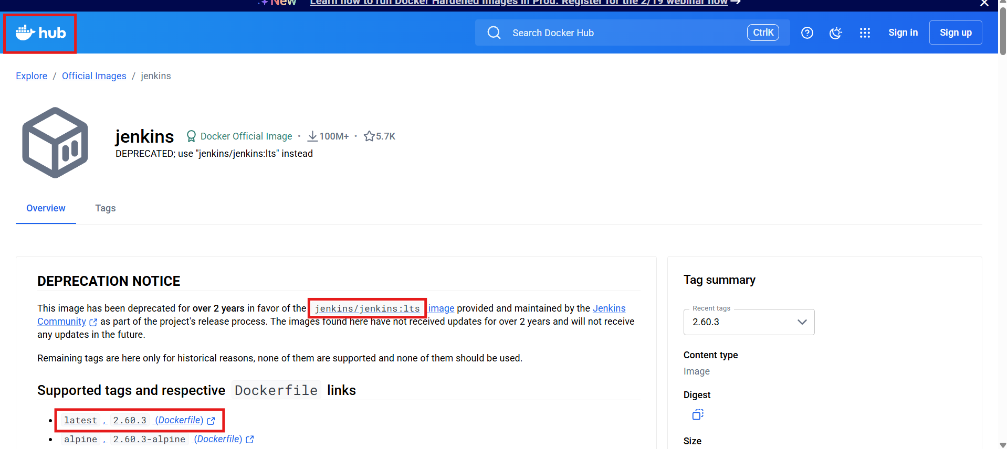
The command docker pull Jenkins/Jenkins:lts worked successfully
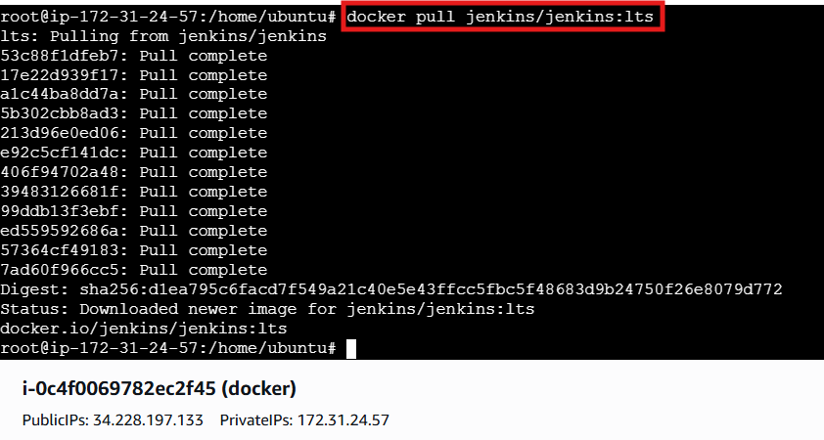

Validating all images using docker images command
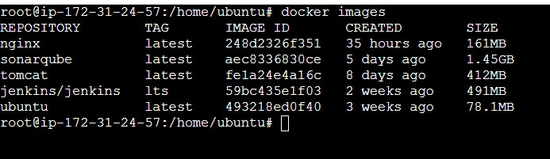
Run nginx container and expose on port 81:80
Use the command docker run -itd -p 81:80 nginx command to run the nginx server and also on 81 port number
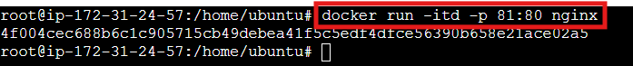
Use the command docker ps to running containers
With the public ip verify on browser
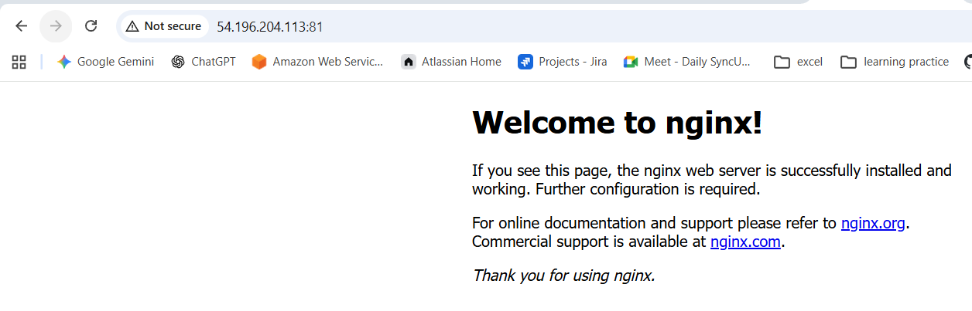

Delete the apache tomcat image from local.
Use the command docker image rmi tomcat to delete the image
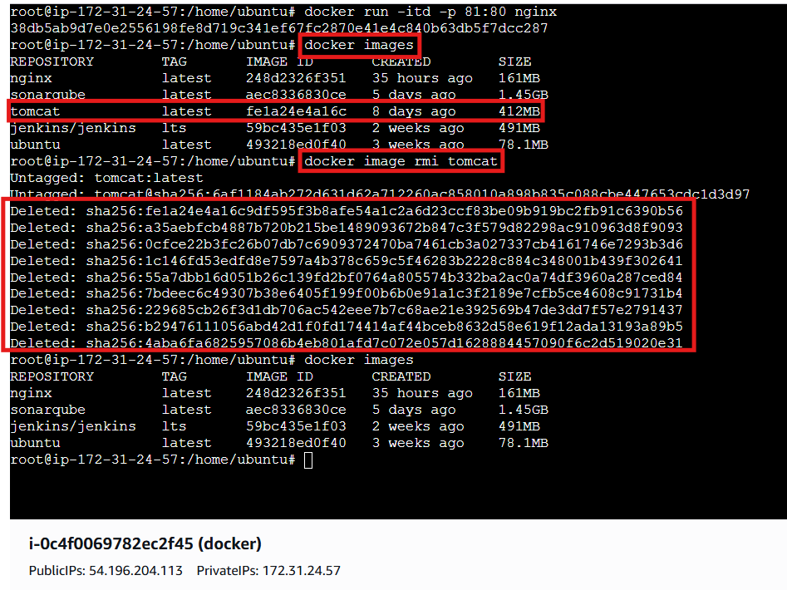

Inspect the jenkins image,sonarqube image
Use the command inspect to get all the details of the images
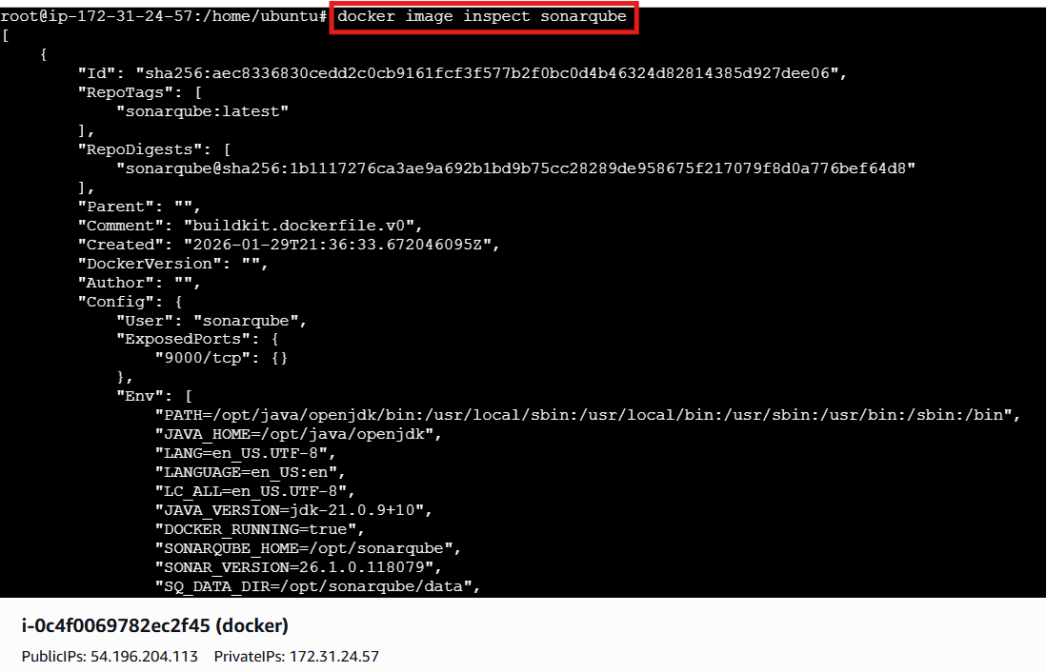
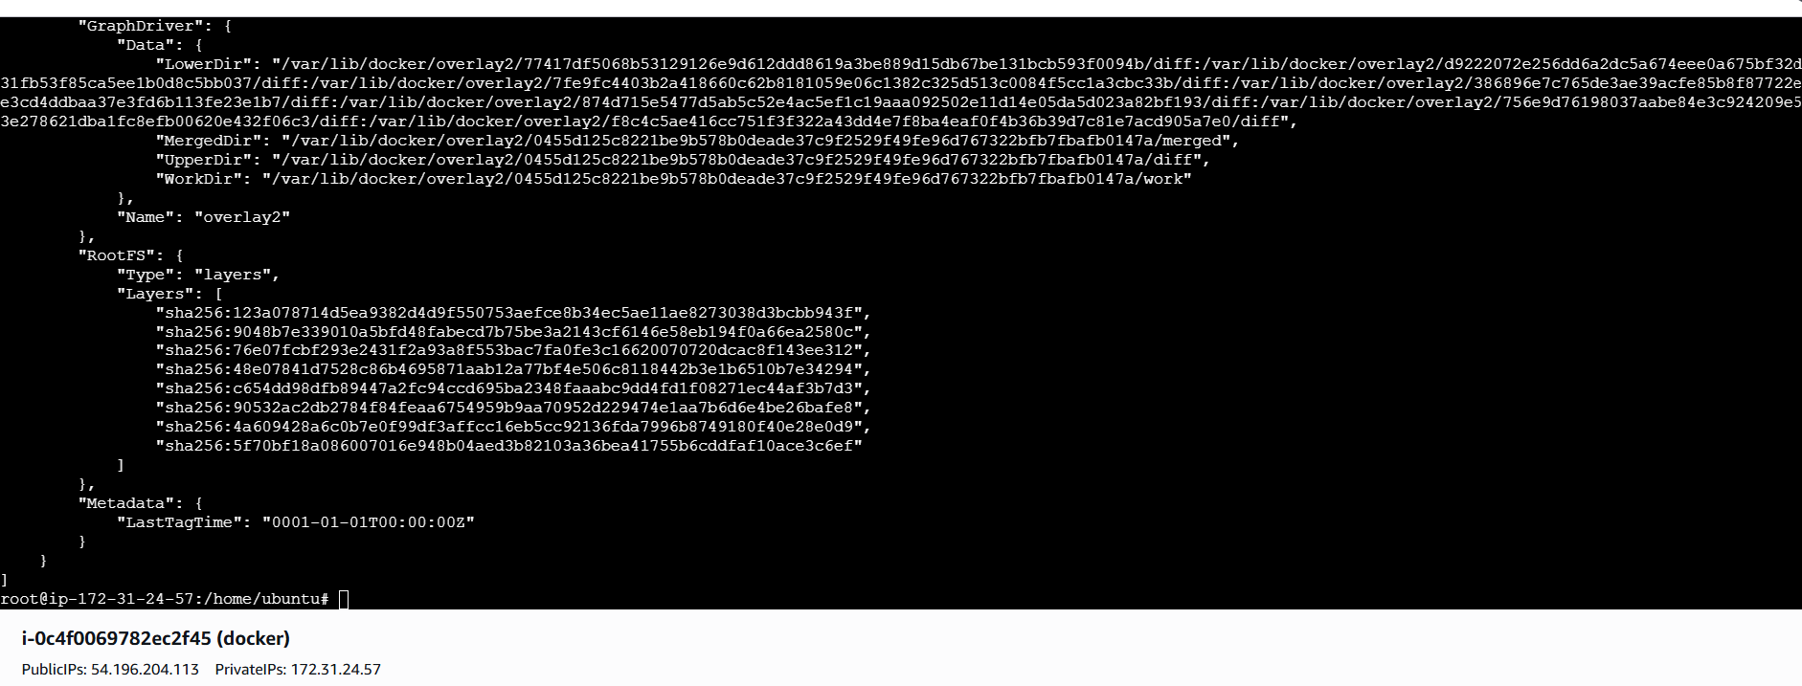
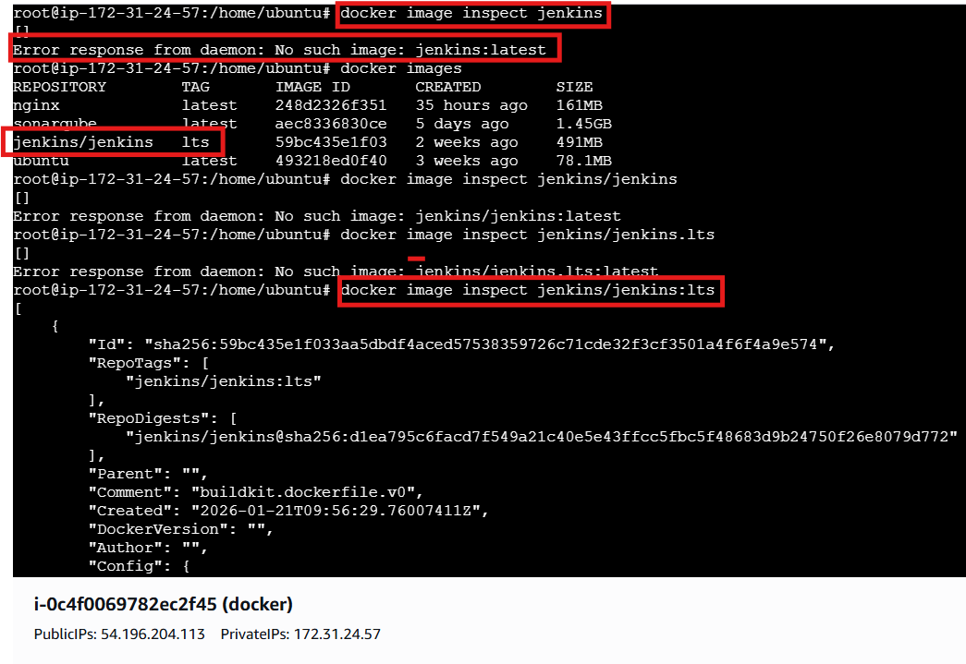
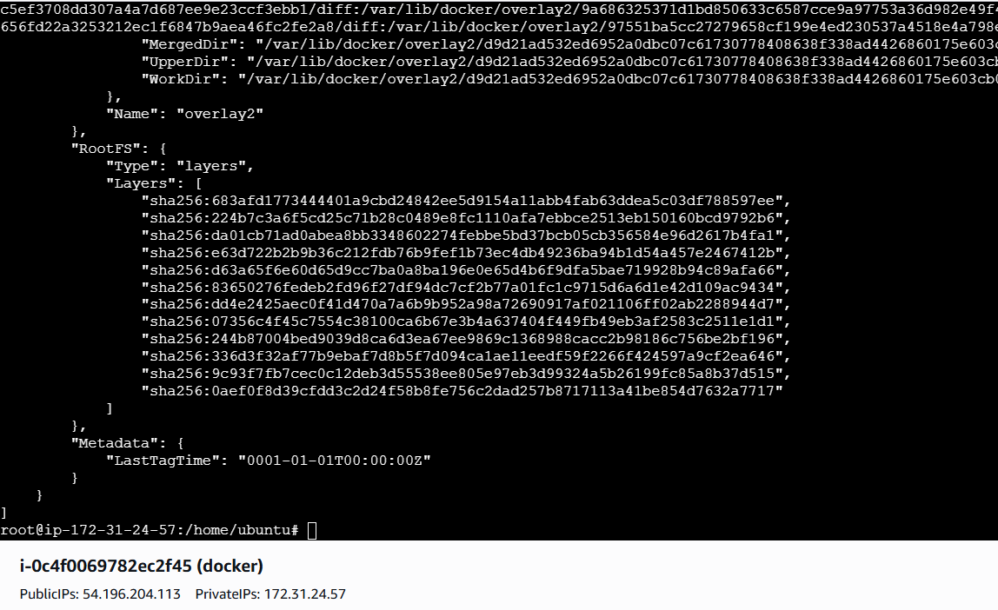

Run jenkins contianer and run one sample job
Run the Jenkins image and access on browser

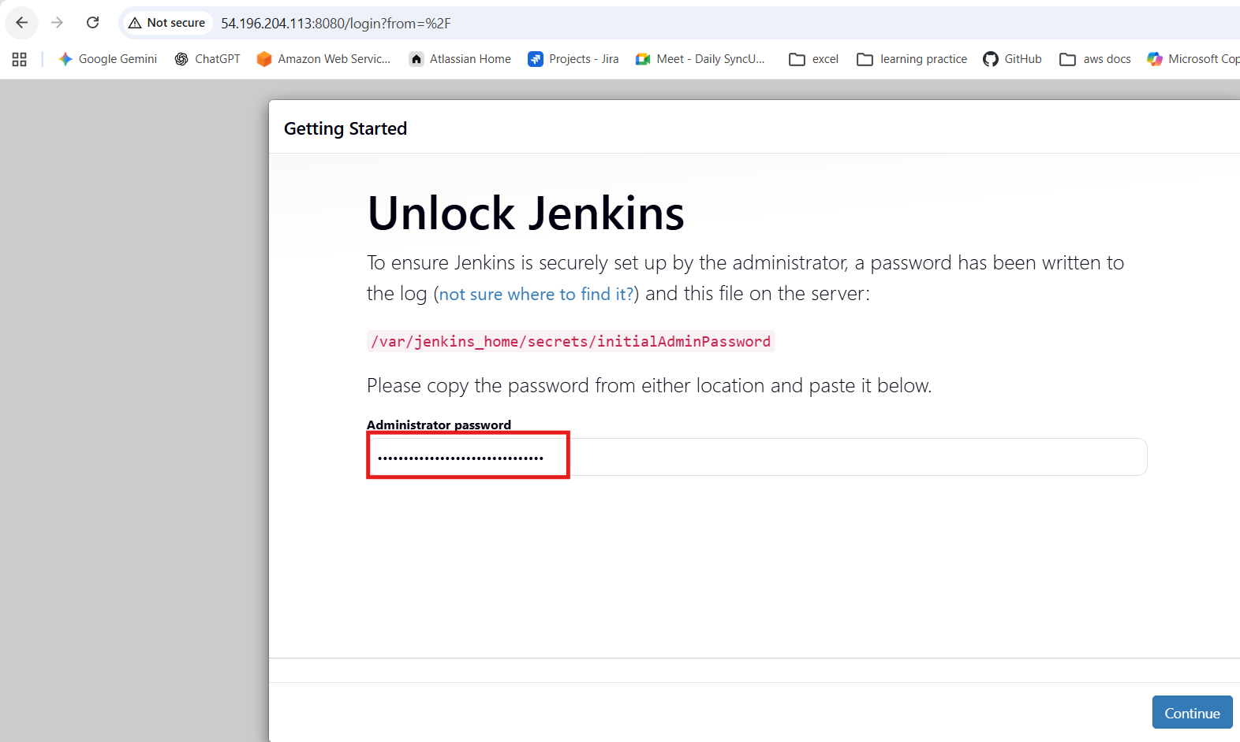
For initial password execute the command
docker exec <container id> cat /var/jenkins_home/secrets/initialAdminPassword
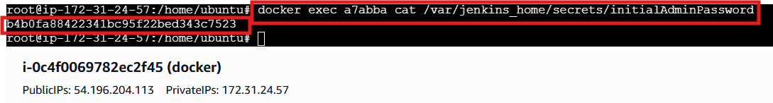

Setup jenkins
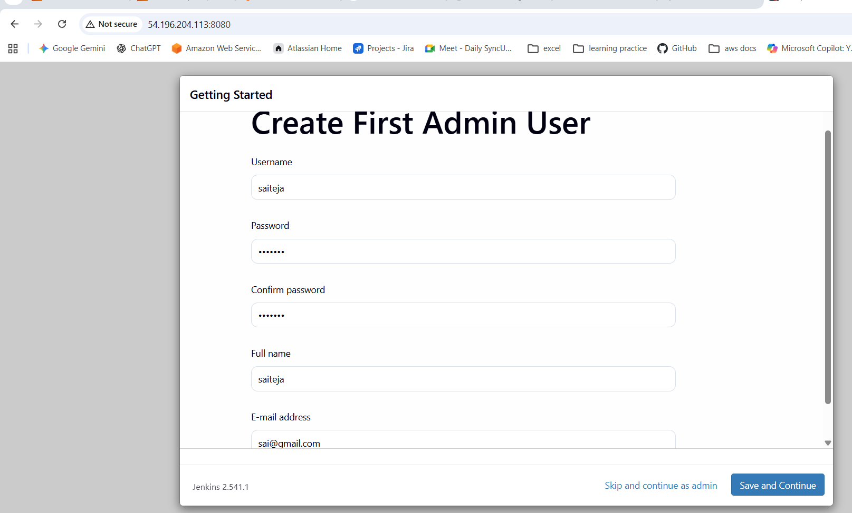
Click on create a job
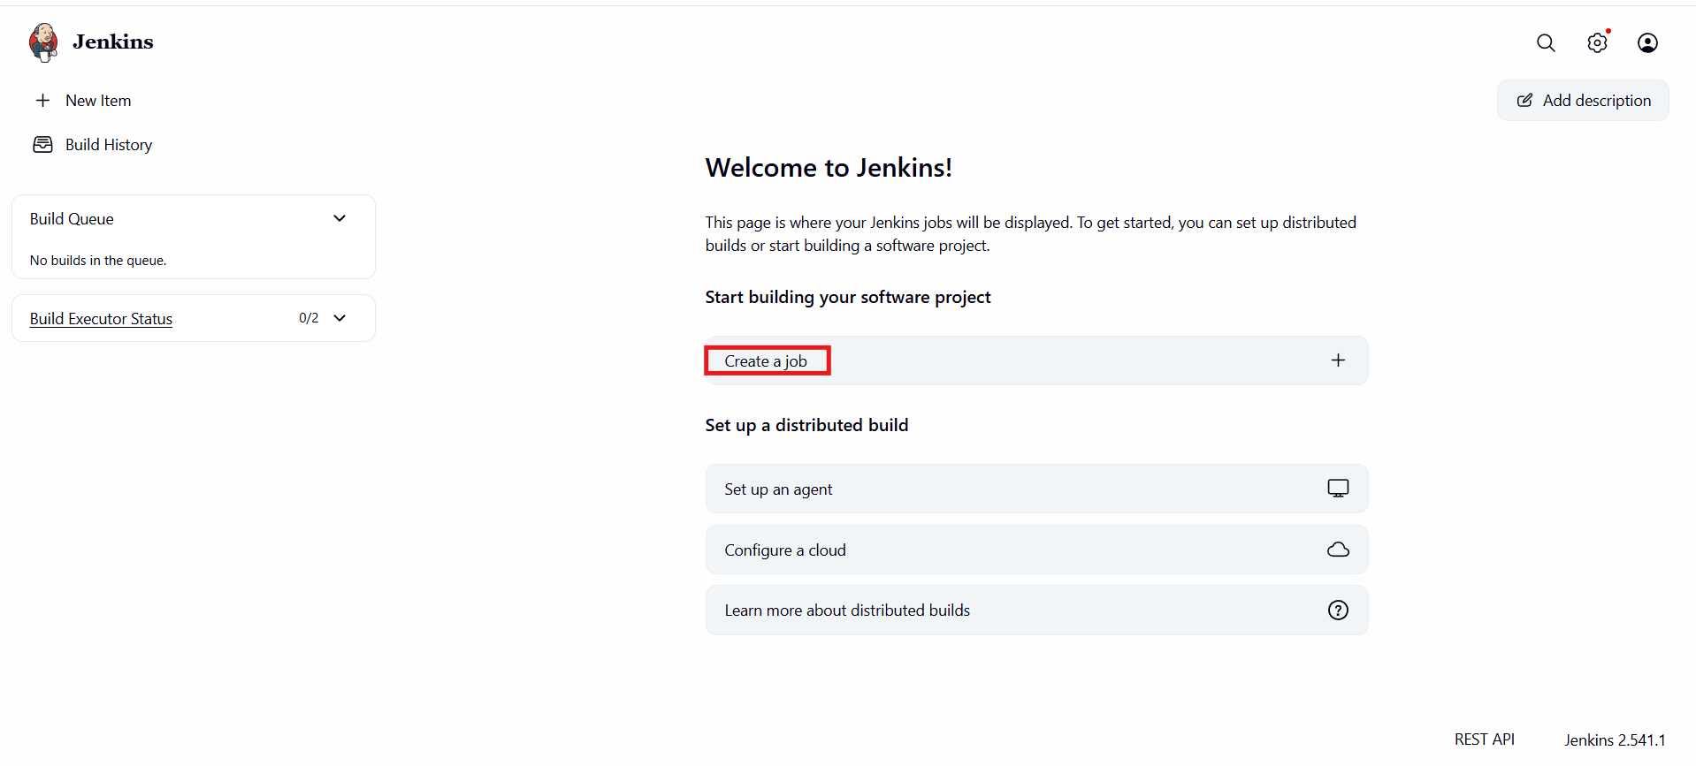

Select the execute shell in build steps and enter some basic commands like echo
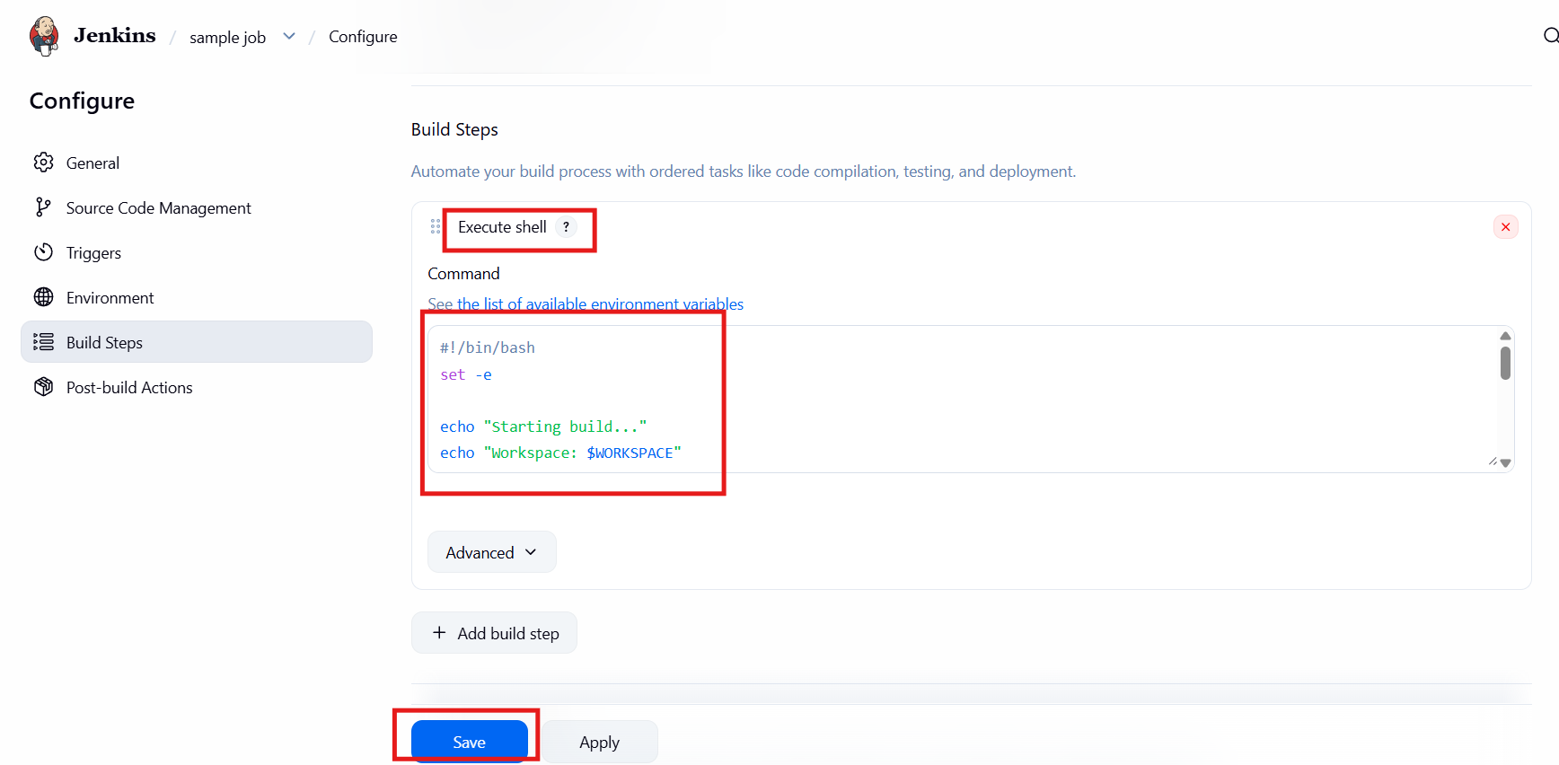
And click on build
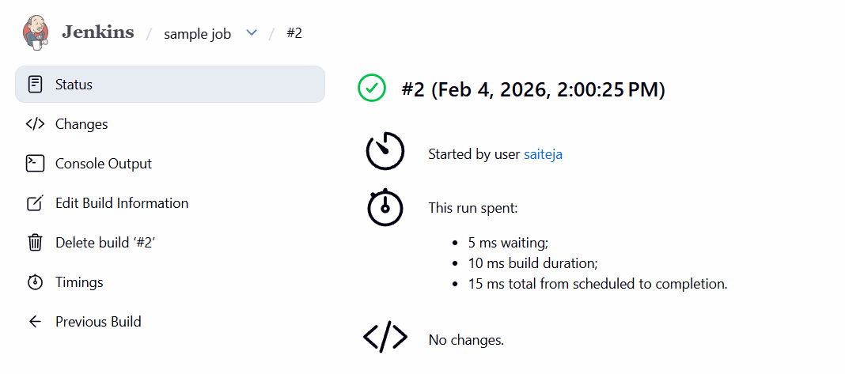
Validating console output
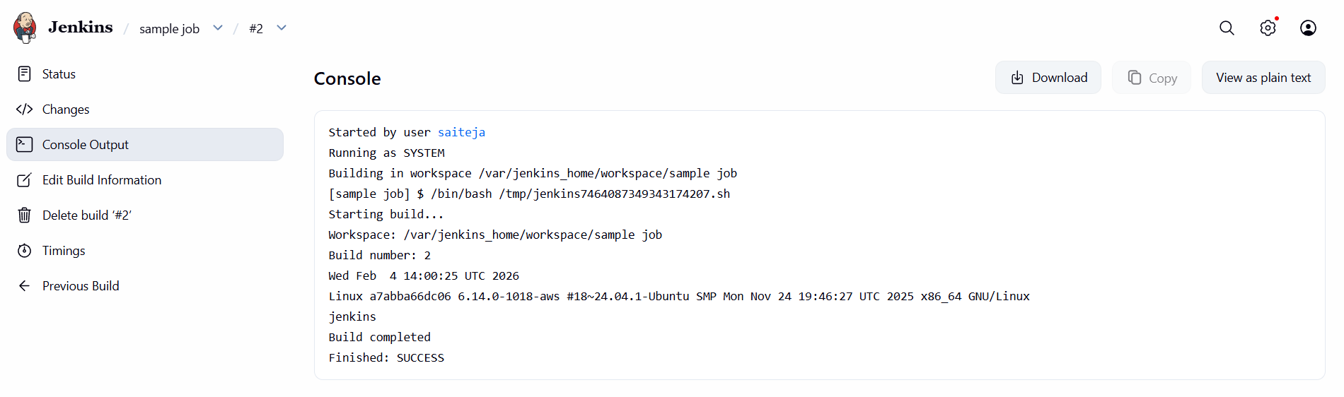

Syntax:
#!/bin/bash
set -e

echo "Starting build..."
echo "Workspace: $WORKSPACE"
echo "Build number: $BUILD_NUMBER"

# Basic commands
date
uname -a
whoami

echo "Build completed"

